
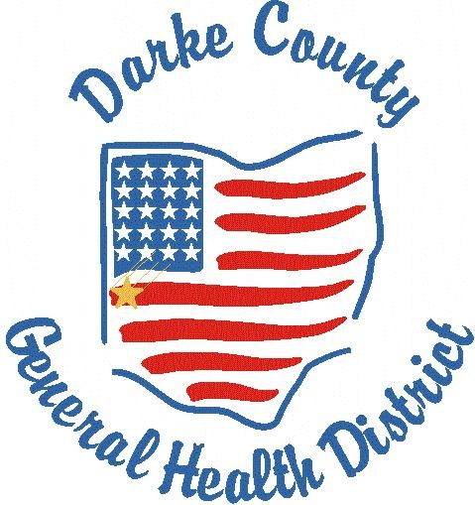 HealthLine
(A newsletter of the Darke County Health Department)

300 Garst Avenue Phone: 937-548-4196 April 2017
Greenville, Ohio 45331 darkecohd@darkecountyhealth.org
The Health Department is now on Facebook & Twitter.
Please “Like us” to receive up to date messages.
Message from the Health Commissioner
Dr. Terry Holman, DVM, RS:
2017 County Health
Rankings Issued;
Recently, the Robert Wood Johnson Foundation issued its county health rankings report. This report helps counties understand what influences the health of residents and how long they will live. The Robert Wood Johnson Foundation collaborates with the University of Wisconsin Population Institute to bring this program to cities, counties, and states across the nation. The Rankings are unique in their ability to measure the current overall health of nearly every county in all 50 states.
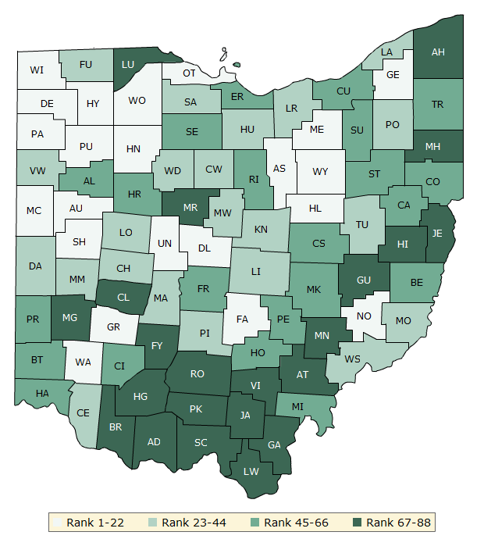
Darke County is ranked 32nd out of 88 counties for Health outcomes, based on equal weighting of length & quality of life.

The Rankings also look at a variety of measures that affect the future health of communities such as high school graduation rates, access to healthy foods, rates of smoking, obesity, and teen births.

Communities use the Rankings to help identify issues and opportunities for local health improvement, as well as garner support for initiatives among government agencies, healthcare providers, community leaders, policy makers, and the public.

The Robert Wood Johnson Foundation also provides a Roadmap that shows what we can do to create healthier places to live, learn, work, and play.

The major goal of the Ranking is to raise awareness about the many factors that influence health and that health varies from place to place, not to produce a list of the healthiest 10 to 20 counties in the nation and only focus on that.

For additional information on this project and how you can make a difference in improving the health of your community, visit: www.countyhealthrankings.org

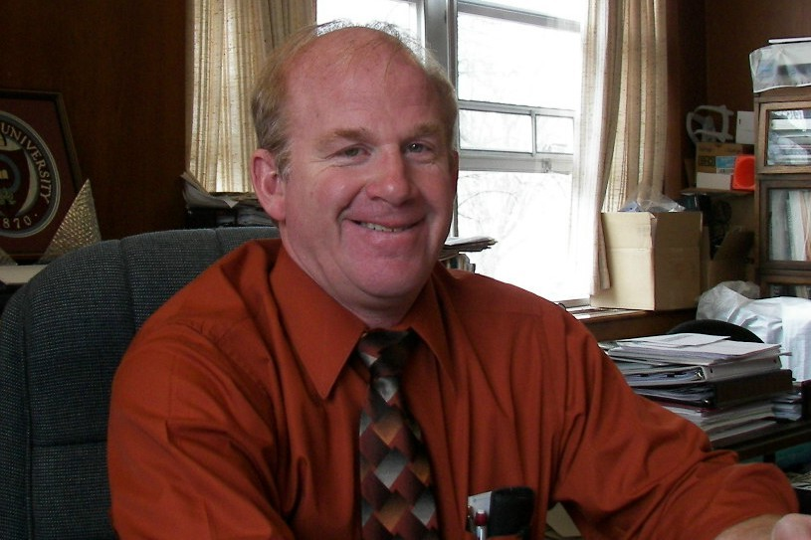


Staff Highlight
New employee: Emily Hoisington
Emily is a graduate of Versailles High School and has an Associate’s Degree in Nursing from Edison Community College. She is currently working towards her Bachelor’s Degree at Ohio University. She currently resides in Versailles with her husband Howard and they are expecting their first child in September. She enjoys spending time with her family and doing anything outdoors. Emily’s main responsibilities will include Help Me Grow home visits, and working as the Communicable Disease nurse as well as immunization nurse.

Tdap/ Menveo
Clinic held April 8, 2017
The Health Department would like to send out a huge THANK YOU to the community for participating in our annual 7th grade and 12th grade Tdap/ Menveo Clinic held on April 8th at Spirit Medical Transport, Greenville, Ohio.
Thank you to Spirit Medical Transport for providing the location and the School Nurses for assisting with the clinic.

We administered 429 vaccines to 271 students. The Tdap vaccine covers immunity for the tetanus, diphtheria, & pertussis (also known as Whooping Cough) diseases. The Menveo vaccine provides protection from meningitis.

22% (271 of the 1232) eligible students in Darke County participated: Way to Go!

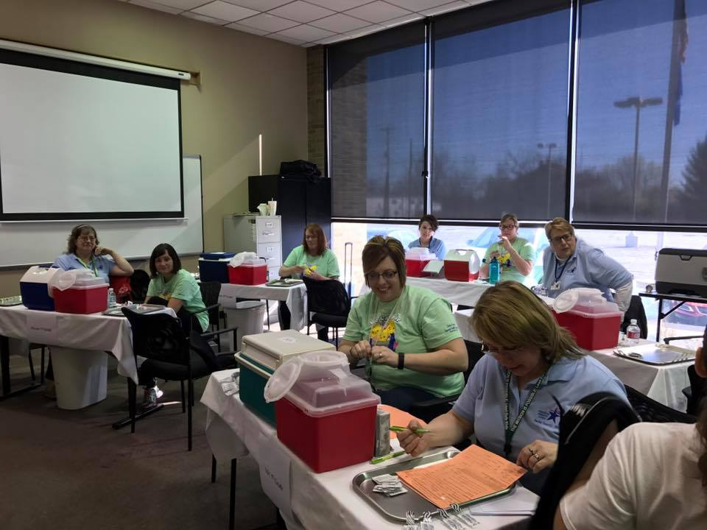
300 Garst Avenue Phone: 937-548-4196 April 2017
Greenville, Ohio 45331 darkecohd@darkecountyhealth.org

Regular Clinic Hours: Tuesdays

Hours: 8:00 – 10:30 a.m.

and 2:00 - 5:00 p.m.
Clinics are walk-in with no appointments needed. Most insurance are accepted.
Call 937-548-4196, extension 224,
with questions or concerns.


Emily Hoisington, RN



Darke County Health Department has an
improved website:

Recently, the Darke County Health Department made improvements to its website to make it more user friendly. A blog was added to the front page to highlight upcoming events. Scroll down tabs were added to make navigation easier. To improve accessibility, a language button was added so the website can be read by any language needed. The website maintained its address and can be viewed at: www.darkecountyhealth.org

Food Inspections Reports Available On-line
Food Service Inspection reports have always been public record. In order to improve accessibility of food inspection reports, these are now available on the health department’s website. Go to www.darkecountyhealth.org, click under Services, then Environmental Health, then Food Service and there is a link to take you to the reports. The reports are organized by facility name. Most facilities are inspected twice a year. Since the inspection reports only indicate the conditions found at the time of the inspection, the last two inspection reports are included. We are excited to provide you this improvement in our website, so you can more easily learn how your local restaurants or grocery stores are doing with their food safety programs.

Please note swimming pool inspection reports and campground inspection reports will be available in the near future.
In addition to our website, please “like us” on Facebook or Twitter to receive updated information from the Health Department.

Staff Highlight
New Accreditation Coordinator

Roberta Mangen, RS, MPH has worked at the Health Department since 1997. She is a graduate of Wright State University with a Bachelor of Science in Environmental Health Science, and she is a graduate of The Ohio State University with a Master’s Degree in Public Health. She recently changed positions from being within the Environmental Department to now being the Health Department’s Accreditation Coordinator. Roberta is responsible for preparing the Health Department’s application to the Public Health Accreditation Board to become an accredited Health Department.
300 Garst Avenue Phone: 937-548-4196 April 2017
Greenville, Ohio 45331 darkecohd@darkecountyhealth.org

Protect yourself from ticks!
Do you know how to prevent yourself from tick bites? Some species of ticks may transmit diseases, which can result in mild to serious illness or death. Cases of Lyme disease have steadily increased in Ohio over the past four years.
Proper protection from ticks and prompt removal are crucial to preventing infection.
Visit http://www.odh.ohio.gov/ticks
for more information!




Health Department Celebrates National Public Health Week: April 3-9, 2017
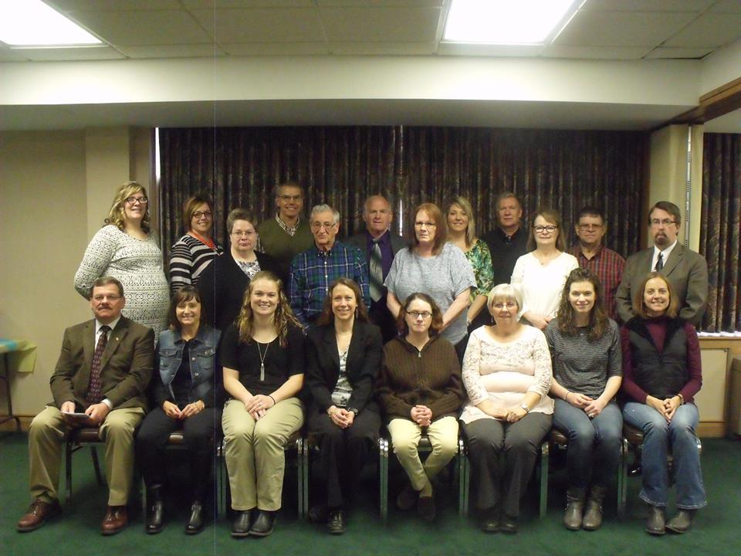 | 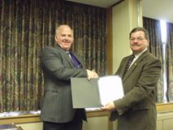 | 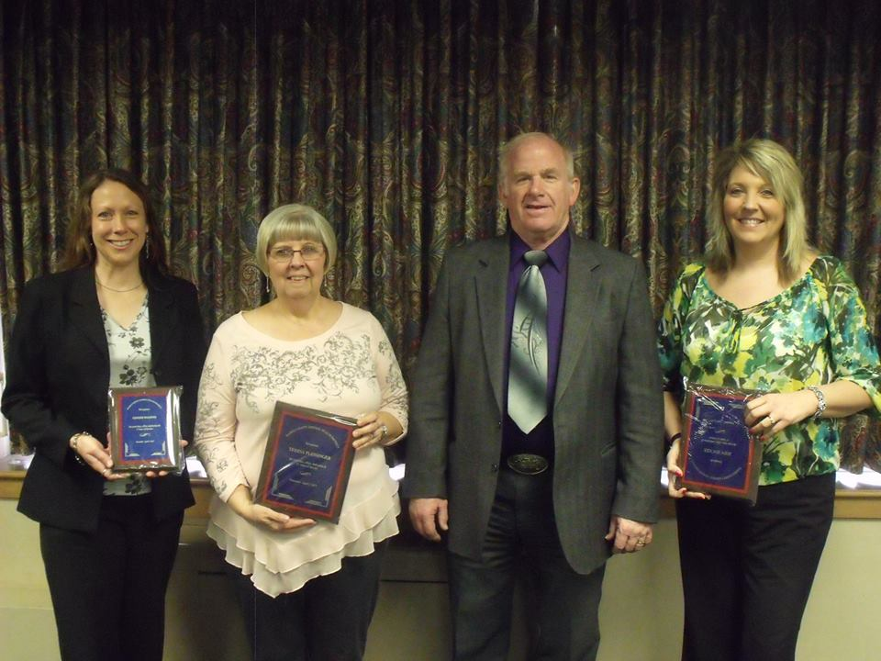

On April 6, 2017, the Darke County Health Department held a program in recognition of its employees and their service to the community. Speakers included: Dennis Wein who presented the Public Health Week Theme and Steve Willman, Greenville City Mayor.
We would like to recognize the following employees for their years of service:
Jody Hocker: 15 years; Teresa Plessinger: 15 years; Ginger Magoto: 5 years

Grant Money Available for Septic System Repair/Replacement

The Darke County Health Department has been awarded an additional $300,000 in grant money to help homeowners repair or replace their failing septic systems.
Homeowners may qualify for the grant money if the house is owner-occupied, the house is not for sale, taxes and mortgage payments are up to date, and the total household income is between 100%-300% the U.S. Department of Health and Human Services Poverty Guidelines. These guidelines are based on the number of people living in the home and their combined yearly income.
For more information, please contact Sophie Hurley, RS: 937-548-4196 ext. 208 or sophie.hurley@darkecountyhealth.org.

www.darkecountyhealth.org
300 Garst Avenue Phone: 937-548-4196 April 2017
Greenville, Ohio 45331 darkecohd@darkecountyhealth.org

