Table of Contents

Table of Figures iii

Chapter 1: Introduction 1

Purpose 1

Mobilizing for Action through Planning and Partnerships (MAPP) 1

Data and Information Sources Contributing to the Assessment 1

Collaborative Process for Sharing and Analyzing Data 1

Report Structure 1

Vision and Values Statements 2

Definition of the Community Served 3

Chapter 2: Significant Health Needs of the Community 4

**Access to Care** 4

Key Research Findings 4

**Aging Population** 6

Key Research Findings 6

**Mental Health and Addiction** 8

Key Research Findings 8

Health Disparities 9

Chapter 3: Demographics of the Population and Social Determinants of Health 12

Demographic Determinants of the Population 12

Social Determinants of Health0F0F 14

Economic Stability 14

Education 17

Neighborhood and the Built Environment 18

Social and Community Context 18

Health and Health Care 19

Chapter 4: Population Health 20

Behavioral Risk Factors 20

Environmental Factors 20

Maternal, Infant, and Child Health Issues 21

Injury and Injury Prevention 22

Infectious and Chronic Disease 23

Infectious Disease 23

Chronic Diseases 23

Mental Health and Substance Use Disorders 25

Chapter 5: Description of Health Disparities and High-risk Populations 26

Factors that contribute to Poorer Health Outcomes 26

Birth Trends 26

Mortality Trends 27

Cancer Trends 28

Food Access 29

Chapter 6: Resource Distribution and Community Assets 30

Access to Health Care 30

Health Insurance 31

Health Care Utilization 33

Health Care Facilities and Professionals 35

Chapter 7: Community Participation and Input 38

Environmental Scan through the Forces of Change Assessment 38

Forces of Change-PESTEL Analysis 38

Strengths, Weaknesses, Opportunities, and Threats (SWOT) Analysis through the Local Public Health System Assessment and the Community Themes and Strengths Assessment 39

Process for consulting with persons representing the community’s interests 39

Primary and Chronic Disease Needs and Other Health Issues of Uninsured Persons, Low-Income Persons, and/or Minority Groups 42

Chapter 8: Discussion and Conclusion 43

Summary of Favorable and Unfavorable Data Trends and Comparisons 43

Process for identifying and prioritizing community health needs and services 43

Stakeholder Commitment for Using the Assessment 44

## Table of Figures

Figure 1: Clinician Type per 100,000 population, 2017 4

Figure 2: Health Insurance Coverage by Age 5

Figure 3: Source of Health Insurance Coverage, 19 years and older 5

Figure 4: Source of Health Insurance Coverage, 19 Years and Under 6

Figure 5: Senior Adult Population Trends, 2010-2050 7

Figure 6: Youth Population Trends, 18 and under, 2010-2050 7

Figure 7: Change in Population by age group, 2020-2030 7

Figure 8: Accidental Drug Overdose, Adults 20 Years of Age or Older, 2014-2018 8

Figure 9: Adult Tobacco Use, Identifying Health Disparities, 2018 9

Figure 10: Youth Tobacco Use, Identifying Health Disparities, 2018 9

Figure 11: Alcohol Use, Identifying Health Disparities, 2018 10

Figure 12: Mental Health Unduplicated Client County, FY2017 11

Figure 13: Unintentional Drug Overdose, Adults 20 Years of Age or Older, 10-year-Age-Adjusted Rate (2009-2018) 11

Figure 14: Population Trends, 2010-2050 12

Figure 15: Youth Population Projections, 2010-2050 12

Figure 16: Senior Population Projections, 2010-2050 13

Figure 17: Race 13

Figure 18: Ethnicity 13

Figure 19: Household Type 13

Figure 20: Marital Status 13

Figure 21: Disabled Population 14

Figure 22: Annual Unemployment, 2014-2018 14

Figure 23: Per Capita and Median Household Income 15

Figure 24: Persons below the Poverty Level by Age 15

Figure 25: Family Poverty 15

Figure 26: Percentage of Individuals Qualifying for Most Public Assistance Programs 16

Figure 27: Percentage of Households Qualifying for Most Public Assistance Programs 16

Figure 28: Percentage of Population Living in Poverty, 2017 16

Figure 29: Educational Attainment for the Population, 25 Years of Age or Older 17

Figure 30: Means of Transportation to Work 18

Figure 31: Land Use 18

Figure 32: Health Insurance Coverage by Age 19

Figure 33: Adult Behavioral Risk Factors, 2018 20

Figure 34: Environmental Problems in the County, 2018 20

Figure 35: First Trimester Care, 2014-2018 21

Figure 36: Breastfeeding at Hospital Discharge, 2014-2018 21

Figure 37: Accidental Drug Overdose, Adults 20 Years of Age and Older, 2014-2018 22

Figure 38: Premature Death Rankings by County 22

Figure 39: Sexually Transmitted Disease (rate per 100,00, 2014-2018 23

Figure 40: Chronic Disease, 2018 23

Figure 41: Comparison of the Top Three Chronic Conditions in the County to Ohio and the US 24

Figure 42: Mental Health Unduplicated Clients, FY 2017 25

Figure 43: Preterm Live Births (<37 weeks gestation, identifying health disparities, 5-year Average (2014-2018) 26

Figure 44: Leading Causes of Adult Death, identifying health disparities, 5-year Rate, 2014-2018 27

Figure 45: Top 3 Adult Cancers by Site, identifying health disparities, 5-year Rate 2014-2018 28

Figure 46: County Health Care Practitioners per 100,000 Population 30

Figure 47: Health Insurance Coverage by Age, 2017 31

Figure 48L Health Insurance Coverage by Age, 2017 32

Figure 49: Health Insurance Coverage by under the Age of 19, 2017 32

Figure 50: Health Care Utilization, 2018 33

Figure 51: Health Care Coverage, Identifying Health Disparities, 2018 33

Figure 52: Delayed Medical Care Because of the Cost, Identifying Health Disparities, 2018 34

Figure 53: Did Not Take Prescribed Medications Because of the Cost, Identifying Health Disparities, 2018 34

Figure 54: Health Care Bills Being Paid Off over Time, Identifying Health Disparities, 2018 34

Figure 55: Access to Health Care Professionals, 2018 35

Figure 56: Has a Personal Doctor or Health Care Provider, Identifying Health Disparities, 2018 35

Figure 57: Saw a Doctor for a Routine Checkup in the Past 12 Months, Identifying Health Disparities, 2018 36

Figure 58: Satisfied with the Health Care Received, Identifying Health Disparities, 2018 36

Figure 59: Health Care Providers 37

# Chapter 1: Introduction

Purpose

The purpose of the Community Health Assessment (CHA)/Community Health Needs Assessment (CHNA)) is to learn about the health of the population, identify contributing factors to higher health risks or poorer health outcomes, and determine what assets and resources are available to improve the population health status.

Mobilizing for Action through Planning and Partnerships (MAPP)

MAPP is a community-wide strategic planning tool for improving public health. More than the absence of illness, health is a dynamic state of complete physical, mental spiritual and social well-being. Such a broad definition of health requires a collective effort. Following the MAPP method helps communities prioritize public health issues, identify resources for addressing them, and take action. The ultimate goal of MAPP is reaching toward optimal community health, a community where residents are healthy, safe, and have a high quality of life.

Darke County General Health District in partnership with Wayne HealthCare and the Applied Policy Research Institute at Wright State University convened with community stakeholders and completed the four steps of the MAPP process. Focus group sessions were held in 2019 and stakeholder meetings began in January 2020 with meetings monthly through April 2020.

Data and Information Sources Contributing to the Assessment

Sources of data for this report include the Ohio Department of Health, Ohio Department of Job and Family Services, the Center for Disease Control and Prevention, the Bureau of the Census’ American Community Survey, the Ohio Department of Public Safety, the Ohio Development Services Agency, the Ohio Mental Health and Addiction Services, the Institute for Health Metrics and Evaluation, the Health Resources and Services Association, the USDA Economic Research Service, and the Robert Wood Johnson Foundation.

## Collaborative Process for Sharing and Analyzing Data

This CHA/CHNA was developed through a collaborative process of collecting and analyzing data, involving many sectors of the community, beyond Darke County General Health District and Wayne HealthCare, participants include Darke County Job and Family Services, Catholic Social Services, the Coalition for a Healthy Darke County, Family Health Services, Brethren Retirement Community, Versailles Health and Rehab, Darke County Recovery and Wellness, Tri- County Board of Recovery and Mental Health, Comprehensive Health Network, County Commissioners office, and the Darke County Sheriff. All of these partners have committed to using the assessment, in which they have highlighted areas for improvement, identified resources, and set the stage to adopt priorities and policies and develop plans to address community health outcomes.

Report Structure

This report illustrates the key health issues faced by County residents along with relevant health disparities affecting community health. Data in this report are organized into topical areas, which can be located by referring to the table of contents. The structure of this report includes: this introduction and description of the process; a demographic discussion of the population; an analysis of the Social Determinants of Health; a community health status report based on four of the Foundational Public Health Areas (Communicable Disease, Chronic Disease, Maternal & Child Health and Access to Care); summaries of focus group sessions; and a summary of the key findings and conclusions. This report compiles primary (newly collected data) and secondary (existing) data to paint a detailed picture of the County and compares the area’s status to state and national data where possible, drawing out critical areas of concern.

## Vision and Values Statements

MOBILIZING FOR ACTION THROUGH PLANNING AND PARTNERSHIPS

logo-expanded

**Our Vision for a Healthy and Vibrant Darke County**

**A healthy community needs more than just access to healthcare. To maintain the health and wellbeing of our community, we must adopt and prioritize specific values vital to a healthy, thriving community. These values include equality, inclusion, access, education, dedication, creativity, and unity. These values should guide the Local Public Health System’s efforts to improve our community’s health.**

**Darke County Community Values:**

**Equality, Inclusion, and Access**

* **Ensure equal opportunities to access health and human services for all community members.**
* **Allocate resources appropriately to secure a healthy, safe, and vibrant community for all to enjoy.**

**Education, Dedication, Creativity, and Unity**

* **Accessible education creates an engaged and knowledgeable community.**
* **Dedication and creativity from key stakeholders in improving community health is vitally important to our rural community.**
* **A united Local Public Health System communicates effectively and protects and promotes the health of our community.**

## Definition of the Community Served

Darke County borders the state of Indiana and is a 30 to 90 minute drive from several major, Midwestern metropolitan communities including: Dayton, Cincinnati, and Columbus in Ohio, and Indianapolis, Indiana. According to the Office of Rural Health Policy, Darke County is considered a rural county. Darke County covers 599.9 square miles and is the second largest county (land mass) in the state of Ohio. Approximately 83.88% (+0.74)* of the county’s land is cropland; 2.01% (-2.48) of the land is pasture; 6.00% (-3.58) of the land is considered forest; 7.20% (+5.04) of land used by residential, commercial, industrial, or transportation uses; 0.19% (+0.08) of the land is open water; and 0.23% (-0.23) of the land is wetlands (woodland/herbaceous).

Darke County’s total population is estimated to be about 51,919. Its largest community and city is Greenville with an estimated 12,694 residents. The Ohio Development Services Agency forecasts Darke County’s overall population to decrease by approximately 10% by the year 2040. The population consists of 97.5% of residents who are white and a total of 1.5% who identify as of Hispanic origin. As of 2018, there were 51,919 people living in Darke County, with 6.0% of the population under 5 years of age, 18.2% between the ages of 6-17 years, only 7.6% between the ages of 18-24 years, nearly half or 49.6% are between the ages 25-64, and 18.6% age 65 and over. Compared to the State of Ohio, Darke County has a higher proportion of children (24.2% versus 22.6%) and a larger proportion of persons 65 and over (18.6% versus 15.9%).

There are 20,803 households in Darke County and 14,355 family households. About 72.5% of housing units are owner-occupied and 27.5% are renter-occupied. In owner-occupied households, 5.1% of homeowners are spending 30% to 50% of their income on housing costs (the recommended percentage is 28%). Nearly 15.0% of renters are spending 30% to 50% of their income on housing costs. Of those family households, 29.0% have children under the age of 18. Of households with children, 8.0% (-1.0) live in a female-headed household with no male present and 3.8%

(-0.06) live in a male-headed household with no female present.

Over half of children who live in poverty are in female-headed households (56.8%). In fact, 11.6% (-2.1) of Darke County’s population lives in poverty; among children under the age of 18, the percentage is 17.5% (-2.1). Among children under the age of 6, the percentage of those living in poverty is estimated to be 18.6% (-0.5). Among those ages 65 and over, the percentage living in poverty is 5.2% (-1.2).

Approximately 10.5% of Darke County’s population does not have a high school diploma. This is nearly equivalent to the state percentage of 10.2%. The percent with a bachelor’s degree or higher is 8.8% (-3.1) versus 17.0% (-8.2) for Ohio. Although Darke County residents are much less likely to have a bachelor’s degree or higher when compared to the state, the County is closely comparable to the average percentage of residents who have completed some college (18.7% in Darke County, 20.5% in the state of Ohio). A sustainable wage for a household of two adults in Darke County is $17.12 (+$2.00) per hour, as long as the person is employed full-time. For a household with one adult and one child, a sustainable wage is $22.47 per hour working full time. (+$4.73)

*Amounts in parentheses () are differences, positive or negative, compared to the same statistics presented in the 2015 Darke County Community Health Assessment.

# Chapter 2: Significant Health Needs of the Community

The CHA captures the social determinants of health that contribute to health status, including but not limited to, housing costs, access to healthy food, availability of recreational space, and physical safety. Chapter 3 discusses local social determinants of health and how they affect the county. Community members and partners have engaged to collect and analyze health-related data and information from a variety of sources. The goal is to inform community decision-making, the prioritization of health problems, improve collaborative efforts, and assist in the development and implementation of planning, policy, and actions to improve the health status of all Darke County residents.

This report illustrates the key health issues faced by Darke County residents along with relevant health disparities affecting community health. The intended audiences include community organizations, civic leaders, public health professionals, healthcare providers and the general public. Strategies for community health improvement will be described in the Community Health Improvement Plan (CHIP), which is a three year strategic plan for community health improvement developed in collaboration with community stakeholders in response to the data analysis completed for the CHA. The following topics have been chosen by the stakeholder group, with consideration of community input, to be the main areas of focus for improving the community’s health.

## **Access to Care**

People without medical insurance are more likely to lack a

regular source of medical care, such as a Primary Care

Physician, and are more likely to skip routine medical care

due to costs, increasing their risk for serious and disabling health

conditions. When they do access health services, they are often

burdened with large medical bills and out-of-pocket expenses.

Increasing access to both routine medical care and medical

insurance are vital steps in improving the health of all Americans.

Healthy People 2020

### Key Research Findings

|  |  |
| --- | --- |
| Access to care barriers include; High cost of care, inadequate or no insurance coverage, Lack of availability of care, lack of culturally competent care which lead to : unmet health needs, financial burdens and preventable hospitalizations  Healthy People 2020. | Figure 1: Clinician Type per 100,000 population, 2017 |

Figure 2: Health Insurance Coverage by Age

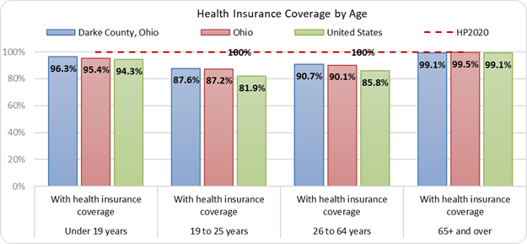

Source: Ohio Department of Health

Figure 3: Source of Health Insurance Coverage, 19 years and older

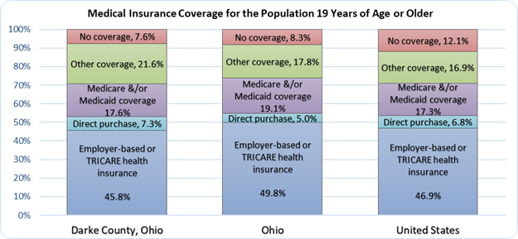

Source: Ohio Department of Health

Figure 4: Source of Health Insurance Coverage, 19 Years and Under

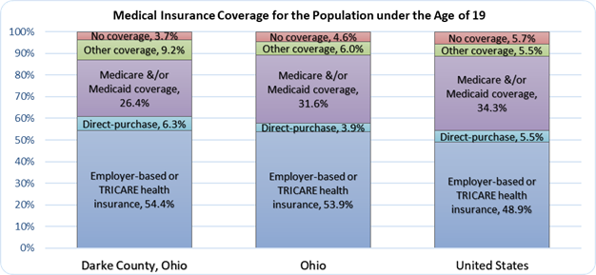

Source: Ohio Department of Health

## **Aging Population**

According to census.gov, the year 2030 marks a demographic turning point for the United States. Beginning that year, all baby boomers will be older than 65 years of age. This will expand the size of the older population so that one in every five Americans is projected to be of retirement age. Later that decade, by 2034, it is projected that older adults will outnumber children for the first time in U.S. history.

***Public Health Importance***

*Aging brings an increase in the prevalence of chronic diseases, such as hypertension, diabetes, arthritis, and dementia. For example, Alzheimer's disease, the most common type of dementia, is the 5th leading cause of death among older Americans. Older**adults also face more challenges with everyday living activities.*

*cdc.gov*

### Key Research Findings

Population trends for the next decade clearly show an increase in senior adults over age 65 all the way through 85+. While youth population trends show no growth at all, and adults age 20-64 will decline. In Darke County, between the years 2020-2030, the age demographics of the community will shift. Senior adults aged 65+ will increase by 3%, while adults aged 20-64 will decrease by 4%. This age demographic shift will put a burden on the employers who provide care for the elderly due to a reduction of individuals in the workforce while increasing the need for services and special care required for the elderly, especially in the over 85 category. In looking further into the future, the over 85 category who most likely will need the most care, grows by 26% from now until 2050.

|  |  |
| --- | --- |
| Figure 5: Senior Adult Population Trends, 2010-2050    Source: Ohio Department of Health |  |

Figure 6: Youth Population Trends, 18 and under, 2010-2050

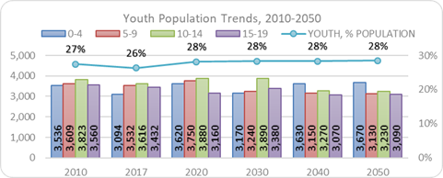

Source: Ohio Department of Health

**Figure 7: Change in Population by age group, 2020-2030**

Source: Ohio Department of Health

## **Mental Health and Addiction**

While Ohio and its counties face many behavioral health challenges, including poor access to care and high prevalence

of depression, the rise in opiate-related drug overdose deaths stands out as an immediate threat to the well-being of Ohioans. Darke County was hit hard in 2017 with an opiate crisis and a high rate of drug overdose. That trend decreased in 2018 while deaths due to heroin overdose saw an increase.

Figure 8: Accidental Drug Overdose, Adults 20 Years of Age or Older, 2014-2018

Source: Ohio Department of Health

### Key Research Findings

*Mental Health: Linked to physical health, mental health can affect work productivity, quality of life, social interaction, diseases, treatments, and outcomes. People who maintain positive mental health are more likely to succeed in life, and more likely to increase their chances of living longer, healthier lives.*

*Tobacco use: Smoking is linked to almost half a million deaths each year in the U.S. Smoking can cause cancer almost anywhere in the body, and increases the risk of developing heart disease and stroke. Women who smoke while pregnant are at an increased risk for having a preterm baby, stillbirth, and infant death.*

*Addiction: Drug use and misuse continue to create public health challenges in the United States, leading to overdose deaths, HIV and hepatitis C infections, and other chronic health conditions (APHA Policy Statement).*

### Health Disparities

Adult Tobacco use is higher in males than females, higher among minorities, lower for those over age 55, significanlty higher for those without a high school diploma, and also significantly higher for those in poverty.

|  |
| --- |
| Figure 9: Adult Tobacco Use, Identifying Health Disparities, 2018  County Source: 2018 County Community Health Assessment Survey  Ohio Source: Behavioral Risk Factor Surveillance System (BRFSS) |
| Figure 10: Youth Tobacco Use, Identifying Health Disparities, 2018    County Source: 2018 County Community Health Assessment Survey |
| Figure 11: Alcohol Use, Identifying Health Disparities, 2018  Source: 2018 County Community Health Assessment |
| Binge drinking is defined as 4 or more alcoholic beverages per occasion for women and 5 or more for men. in the u.s., 1 in 6 people binge drink.  cdc.gov  *Alcohol Use: Excessive alcohol consumption is associated with numerous health problems. Unintentional injuries, such as motor vehicle crashes, falls, burns, and drowning are often tied to alcohol use. Intentional injuries associated with alcohol use include firearm injuries, sexual assaults, and domestic violence. Long-term health risks include liver disease, depression, anxiety, high blood pressure, stroke, heart attack, cancer, and uncontrollable diabetes. Pregnant women who drink risk having a child born with fetal alcohol spectrum disorders.*  Figure 12: Mental Health Unduplicated Client County, FY2017  Source: Ohio Department of Mental Health and Addiction Services  Public health importance  Behavioral health describes the connection between a person’s behaviors and the health and well-being of the body and mind (CDC 2019).Behavioral risk factors include any particular behavior or behavior pattern which negatively impacts health. These risk factors increase the chances of developing a disease, disability, or syndrome. Positive health behaviors will increase health.  [Cite your source here.] |
|  |
|  |
|  |
|  |
|  |

Figure 13: Unintentional Drug Overdose, Adults 20 Years of Age or Older, 10-year-Age-Adjusted Rate (2009-2018)

Source: Ohio Department of Health

|  |  |
| --- | --- |
|  | |
|  |  |
|  |

# Chapter 3: Demographics of the Population and Social Determinants of Health

## Demographic Determinants of the Population

|  |  |  |  |
| --- | --- | --- | --- |
| A large and growing body of evidence shows that sociodemographic factors – such as age, race, and ethnicity – and socioeconomic status (SES), such as income and education, can influence health outcomes. | | Figure 14: Population Trends, 2010-2050  Source: American Community Survey, 2013-2017  Ohio Development Services Agency | |
| Figure 15: Youth Population Projections, 2010-2050  Source: American Community Survey, 2013-2017, Ohio Development Services Agency | | | https://phil.cdc.gov/PHIL_Images/11359/11359_lores.jpg |
|  | Figure 16: Senior Population Projections, 2010-2050  Source: American Community Survey, 2013-2017 and the Ohio Development Services Agency | | |

|  |  |  |
| --- | --- | --- |
| Figure 17: Race  Source: American Community Survey, 2013-2017 | | Figure 18: Ethnicity  Source: American Community Survey, 2013-2017 |
| Figure 19: Household Type  Source: American Community Survey, 2013-2017 | https://phil.cdc.gov/PHIL_Images/11317/11317_lores.jpg | Figure 20: Marital Status  Source: American Community Survey, 2013-2017 |
|  | | |

Figure 21: Disabled Population

## Social Determinants of Health0F0F0F[1]

Social determinants of health are conditions in the environments in which people are born, live, learn, work, play, worship, and age that affect a wide range of health, functioning, and quality-of-life outcomes and risks.

### Economic Stability

|  |  |
| --- | --- |
| Figure 22: Annual Unemployment, 2014-2018    Source: Ohio Dept. of Job & Family Services, Local Area Unemployment Statistics (LAUS) Program  Darke County offers several manufacturing jobs that help keep unemployment low and families maintain financial stability. The majority of these jobs are achievable with a high school diploma. However, families with children make up the largest population of those living in poverty in the county. The rural nature of the county makes those living below or slightly above the poverty level even harder, potentially due to the lack of reliable transportation, to maintain employment or have access to grocery stores. | |
| Figure 23: Per Capita and Median Household Income  Source: American Community Survey, 2013-2017 | Public Health Importance: A person’s health is linked to their economic and educational status. Economic stability is influenced by employment, food insecurity, housing instability, and poverty.  [Cite your source here.] |
| Figure 24: Persons below the Poverty Level by Age | Figure 25: Family Poverty |
| Figure 26: Percentage of Individuals Qualifying for Most Public Assistance Programs  Source: American Community Survey, 2013-201  *Darke County ranks 66th out of 88 counties in the state of Ohio* for the percentage of persons living in poverty, which means there are 65 other counties in Ohio who have more people living in poverty in their county than we do in ours.*  *\*RWJ County Health Rankings* | Figure 27: Percentage of Households Qualifying for Most Public Assistance Programs |

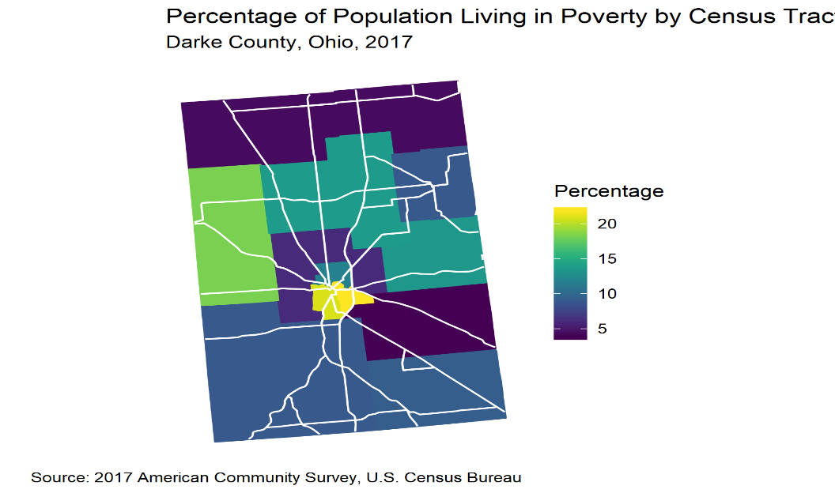**Figure 28: Percentage of Population Living in Poverty, 2017**

### Education

Public Health Importance: Level of education is one of the greatest predictors of individual health. Early childhood education provides a foundation for children’s academic success, health, and general well-being. Higher educational attainment allows for better paying jobs with resources like health benefits, paid leave, retirement accounts, easier access to healthy foods and services, and more time for exercise.

|  |  |
| --- | --- |
| **Figure 29: Educational Attainment for the Population, 25 Years of Age or Older**  **Source: American Community Survey, 2013-2017** |  |

Compared to the state and nation, Darke County has a much higher rate of high school graduates, yet lower rate of higher level of education. The lower rates of college level education may have some impact on the community. While the area has a strong agricultural presence as well as manufacturing, which may account for the educational attainment statistics, these professions in and of themselves bring a level of concern for health issues.

*Darke County High School Mascots*









### Neighborhood and the Built Environment

Public Health Importance: The built environment includes all of the physical aspects of where we live, and influences a person’s level of physical activity. Access to healthy foods, quality of housing, environmental conditions, and crime and violence comprise the HP 2020 list for this determinant.

Darke County is a rural area and public transportation is provided by appointment and not offered as regular daily routes. The majority of the population use their own vehicle as a means of transportation.

|  |  |
| --- | --- |
| Figure 30: Means of Transportation to Work    Source: American Community Survey, 2013-2017 | Figure 31: Land Use |
|  | Source: Ohio Development Services Agency, Office of Research, Ohio County Profiles, 2019 |

### Social and Community Context

Public Health Importance: “Social isolation predicts morbidity and mortality from cancer, cardiovascular disease, and a host of other causes.”1F1F1F[2] Civic participation, incarceration, and social cohesion are the main elements for this determinant.

In a risk and protective factors survey of 600 households in Western Ohio, it was found that:

* 8% of adults have no one they can turn to when they are lonely
* 3% have no one to talk to when in a crisis
* From a neighborhood perspective, 26% of families never or rarely pull together in stressful times
* Many families don’t know where to turn, if the family needed it, for food (6%), housing (12%), or to make ends meet (13%)

With the increase in the aging population combined with the rural nature of the county, the issue of isolation is a factor to consider when addressing social determinants of health. Isolation must also be considered for those dealing with mental health and substance abuse issues. Availability of mental health care providers continues to be a struggle. Information gathered through the focus groups suggest those who struggle the most do not feel the area offers a sense of community and understanding of those in need.

### Health and Health Care

Public Health Importance: Uninsured people receive less medical care and less timely care, they have worse health outcomes, and lack of insurance is a financial burden for them and their families (Urban Institute urban.org).

Figure 32: Health Insurance Coverage by Age

Source: American Community Survey, 2013-2017

Social determinants of health in Darke County are those that are commonly found in rural counties throughout the United States. Beyond a few of the basic health determinants that go along with rural communities, like transportation, poverty and low health literacy, the county is labeled as a Health Professional Shortage Area. As the chart above shows, rates of insurance coverage are better than both the state and nation. However, having coverage means nothing when there are few, if any, doctors and/or specialists available to provide care. More so if you have coverage but are still at a lower income level limiting the ability to travel out of the area for specialty care or simply not having the extra money it takes to cover costs not paid by insurance.

According to the 2018 Behavioral Risk Factor Survey conducted in Darke County, nearly 70% of the population report as overweight or obese and the most prevalent chronic health issues include high blood pressure and high cholesterol. Avoiding preventative care leads to increased incidence of chronic health conditions, emergency room visits and premature death. Poor access to healthy foods, common in rural areas, can lead to obesity. Residents feel more choices for healthy and affordable food should be available when going out to eat.

Darke County does not present as a highly poverty stricken community, but the largest percent of the population who fall into the poverty category are those under the age of 19. We know that children who grow up where they feel uncertain about basic needs, such as food and housing, have a higher risk of chronic disease incidence later in life. They are also more likely to have substance abuse issues. Many residents shared the importance of free community events for families with children. As the population shifts in the county, in focusing on chronic disease, we must keep in mind how much the support of young families lays a foundation of better health throughout the lifespan.

# Chapter 4: Population Health

Population health is defined as the health outcomes of a group of individuals, including the distribution of such outcomes within the group. This section of the report will present health outcomes for groups of individuals in Darke County including the distribution within groups.

## Behavioral Risk Factors

Examples of behavioral risk factors include tobacco use, alcohol consumption, obesity, physical inactivity, and unsafe sexual activity.

|  |  |
| --- | --- |
| Public Health Importance: Behavioral risk factors include any particular behavior or behavior pattern which strongly yet adversely affects health. It increases the chances of developing a disease, disability, or syndrome.  Centers for Disease Control and Prevention | Figure 33: Adult Behavioral Risk Factors, 2018  Source: 2018 County Community Health Assessment Survey |
|  |  |

## Environmental Factors

Public Health Importance: Poor environmental quality has its greatest impact on people whose health status is already at risk. According to the World Health Organization, almost a quarter of all deaths are attributable to preventable environmental factors.

Public Health Importance: People interact with the environment constantly. These interactions affect quality of life, years of healthy life lived, and health disparities.

Healthy People 2020

|  |  |
| --- | --- |
| Figure 34: Environmental Problems in the County, 2018  Source: 2018 County Community Health Assessment Survey |  |

## Maternal, Infant, and Child Health Issues

|  |  |  |
| --- | --- | --- |
| Public Health Importance: Maternal and infant health includes infant and maternal mortality, birth outcomes and related risk factors impacting preconception, pregnancy and infancy such as teen pregnancy.  Centers for Disease Control and Prevention | Figure 35: First Trimester Care, 2014-2018  Source: Ohio Department of Health | |
| Figure 36: Breastfeeding at Hospital Discharge, 2014-2018  Source: Ohio Department of Health | |  |

**Social determinants of health that effect breastfeeding rates:**

**Women who**

* + **Have higher level of education**
  + **are 30 years of age or older**
  + **are married**
  + **have higher household income**

**are more likely to breastfeed**

**Breastfeeding provides positive health benefits for both mom and baby**

**- astho.org**

## Injury and Injury Prevention

|  |
| --- |
| Public Health Importance: Injuries result in more deaths than all other causes for people aged 1 to 44 years. Injuries are an enormous threat to our communities, a threat for which we have an array of effective prevention strategies.  Centers for Disease Control and Prevention |
| Figure 37: Accidental Drug Overdose, Adults 20 Years of Age and Older, 2014-2018  Source: Ohio Department of Health |

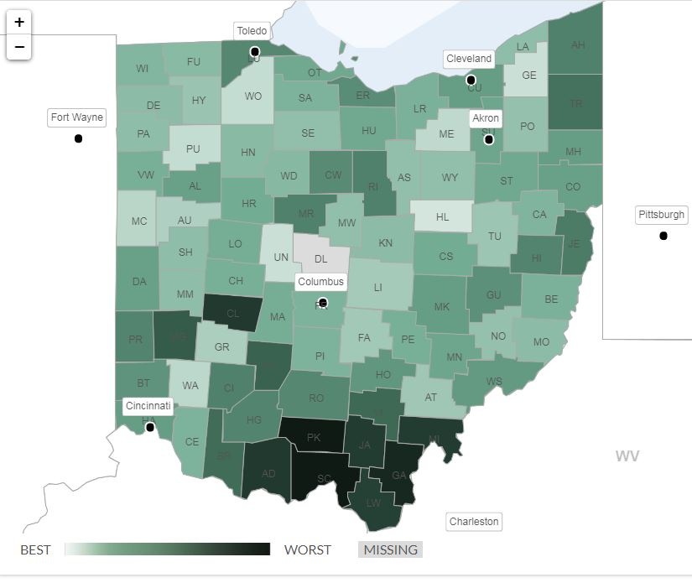**Figure 38: Premature Death Rankings by County**

Premature Death is defined as the potential years of life lost before age 75 per 100,000 population (age-adjusted). Darke County ranks 53 out of 88 counties in Ohio.

|  |  |  |
| --- | --- | --- |
| Infectious and Chronic DiseaseInfectious Disease | Public Health Importance: Infectious diseases are disorders caused by organisms — such as bacteria, viruses, fungi or parasites.  Mayo Clinic  Figure 39: Sexually Transmitted Disease (rate per 100,000, 2014-2018)  Source: Ohio Department of Health | |
|  |  |  |

### Chronic Diseases

Chronic disease includes heart disease, stroke, diabetes, cancer, chronic obstructive pulmonary disease/chronic lower respiratory disease, asthma, and arthritis. It also includes related clinical risk factors (obesity, hypertension and high cholesterol), as well as behaviors closely associated with these conditions and risk factors (nutrition, physical activity and tobacco use).

|  |  |
| --- | --- |
| Figure 40: Chronic Disease, 2018  Source: County Survey | Public Health Importance: about half of all adults had one or more chronic health conditions and one of four adults had two or more chronic health conditions and two of the top ten causes of death account for almost half (48 percent) of the deaths in the United States – heart disease and cancer.  CDC |
| Figure 41: Comparison of the Top Three Chronic Conditions in the County to Ohio and the US  Source: County Survey CDC BRFSS Prevalence and Trends  Darke County has a higher incidence of diabetes than the state of Ohio and the United States. | |
| Image by [Steve Buissinne](https://pixabay.com/users/stevepb-282134/?utm_source=link-attribution&utm_medium=referral&utm_campaign=image&utm_content=867855) from [Pixabay](https://pixabay.com/?utm_source=link-attribution&utm_medium=referral&utm_campaign=image&utm_content=867855) | |

## Mental Health and Substance Use Disorders

Mental health includes our emotional, psychological, and social well-being. It affects how we think, feel, and act. It also helps determine how we handle stress, relate to others, and make choices.

|  |  |
| --- | --- |
| Public Health Importance: Linked to physical health, mental health can affect work productivity, quality of life, social interaction, diseases, treatments, and outcomes. People who maintain positive mental health are more likely to succeed in life, and more likely to increase their chances of living longer, healthier lives.  U.S. Department of Health & Human Services | Figure 42: Mental Health Unduplicated Clients, FY 2017  Source: Ohio Department of Mental Health and Addiction Services |

# Chapter 5: Description of Health Disparities and High-risk Populations

Health disparities are preventable differences in the burden of disease, injury, violence, or opportunities to achieve optimal health that are experienced by socially disadvantaged populations.2F2F2F[3] Populations can be defined by factors such as race or ethnicity, gender, education or income, disability, geographic location (e.g., rural or urban), or sexual orientation. Health disparities are inequitable and are directly related to the historical and current unequal distribution of social, political, economic, and environmental resources.

## Factors that contribute to Poorer Health Outcomes

### Birth Trends

#### Premature Birth

.**PUBLIC HEALTH IMPORTANCE**

Infant mortality: In addition to life expectancy, infant mortality is an important indicator of the overall health of a community. Ohio has one of the highest infant mortality rates in the U.S. A significant proportion of infant deaths occurs when infants are born too early and too small.

|  |
| --- |
| Factors that Contribute to Poorer Health Outcomes: Babies born prematurely can suffer from many lifelong medical conditions that affect their heart, lungs, intestines, kidneys, and eyes. As these babies mature, developmental delays and learning disabilities often appear.  March of Dimes |
| Figure 43: Preterm Live Births (<37 weeks gestation, identifying health disparities, 5-year Average (2014-2018)    Source: Ohio Department of Health |

### Mortality Trends

Several protective factors that have registered substantial average increases (e.g., physical activity among adults, high blood pressure control, and human papillomavirus vaccination among adolescent females) have stalled in recent years.3F3F3F[4] Many protective factors, even those with impressive relative gains, still represent only a minority of the U.S. population (e.g., control of high cholesterol at 29.5%).

|  |
| --- |
| Factors that Contribute to Poorer Health Outcomes:Age-adjusted rates for most of the leading causes of death are declining, but in some cases, the number of deaths is increasing ... heart disease, cancer, or accidents are the leading causes of premature death.  Gardner JW, et al. Epidemiology |
| Figure 44: Leading Causes of Adult Death, identifying health disparities, 5-year Rate, 2014-2018  Source: Ohio Department of Health |

### Cancer Trends

|  |
| --- |
| Factors that Contribute to Poorer Health Outcomes: Daily habits like smoking, poor diet, and little physical activity increase the risk for cancer. Education, housing, income and occupation are factors that can contribute to cancer. For example, stomach and cervical cancers are higher in lower socioeconomic groups, as is lung cancer.  American Cancer Society |
| Figure 45: Top 3 Adult Cancers by Site, identifying health disparities, 5-year Rate 2014-2018  Source: Ohio Department of Health |

Cancer Association of Darke County

### Food Access

|  |
| --- |
| Factors that Contribute to Poorer Health Outcomes: Neighborhoods without access to quality, healthy food frequently rely on what is available at local convenience stores. Many of the foods provided in convenience stores are high in calories and low in nutrition, contributing to future health complications such as obesity, diabetes, heart disease, and hypertension.  Healthy People 2020 |
|  |
|  |

# Chapter 6: Resource Distribution and Community Assets

## Access to Health Care

Access to quality medical professionals and facilities is crucial in maintaining and promoting good health, preventing and managing various disease states, reducing avoidable and preventable sickness and death, and providing equality in health care for all. Perceived and true barriers to accessing providers and care may include geographic location, socioeconomic status and insurance coverage status, high cost of treatment, lack of service availability, sex, race, ethnicity, disability status, sexual orientation, and lack of cultural competence in care. These barriers enable unmet health needs to continue, further contributing to future health complications.

Figure 46: County Health Care Practitioners per 100,000 Population

## Health Insurance

The increasing size and prevalence of high deductibles and copayments in private health plans, including employer-based plans, are leading many people with low and moderate incomes to avoid or delay needed health care. Health insurance coverage data provided below show most residents have health insurance coverage. However, healthcare utilization was lacking in some cases due to additional costs related to doctor visits and medicine. In the Delayed Health Care Because of Cost chart (Figure 52), every demographic listed is higher than the Healthy People 2020 goal of 4.2%. These results are significant when looking at how to improve access to care, while coverage is necessary, it is not automatically indicative of the ability to seek care.

|  |
| --- |
|  |
| Public Health Importance: Health insurance is important for several reasons. Uninsured people receive less medical care and less timely care, they have worse health outcomes, and lack of insurance is a financial burden for them and their families.  Urban Institute  Figure 47: Health Insurance Coverage by Age, 2017    Source: American Community Survey, 2013-2017 |
| Figure 48L Health Insurance Coverage by Age, 2017    Source: American Community Survey, 2013-2017 |
| Figure 49: Health Insurance Coverage by under the Age of 19, 2017    Source: American Community Survey, 2013-2017 |

### Health Care Utilization

|  |  |
| --- | --- |
| Public Health Importance: People use health care for many reasons including preventing and curing health problems, promoting maintenance of health and well-being, or obtaining information about their health status and prognosis.  Encyclopedia of Behavioral Medicine | Figure 50: Health Care Utilization, 2018  Source: 2018 County Community Health Assessment Survey |

|  |
| --- |
| Figure 51: Health Care Coverage, Identifying Health Disparities, 2018  Source: 2018 County Community Health Assessment Survey |
| Figure 52: Delayed Medical Care Because of the Cost, Identifying Health Disparities, 2018  Source: 2018 County Community Health Assessment Survey |
| Figure 53: Did Not Take Prescribed Medications Because of the Cost, Identifying Health Disparities, 2018  Source: 2018 County Community Health Assessment Survey |

|  |
| --- |
| Figure 54: Health Care Bills Being Paid Off over Time, Identifying Health Disparities, 2018  Source: 2018 County Community Health Assessment Survey |

## Health Care Facilities and Professionals

|  |  |
| --- | --- |
| Health professionals play a central and critical role in improving quality health care for the population. They provide essential services that promote health, prevent diseases, and deliver health care services to individuals, families and communities. Health care facilities should reflect the needs and values of the communities in and around them. Effective hospitals are designed for their users, with attention to the needs of special populations, such as children and the elderly.  Encyclopedia of Behavioral Medicine | Figure 55: Access to Health Care Professionals, 2018  Source: 2018 County Community Health Assessment Survey |
| Figure 56: Has a Personal Doctor or Health Care Provider, Identifying Health Disparities, 2018  Source: 2018 County Community Health Assessment Survey | |
| Figure 57: Saw a Doctor for a Routine Checkup in the Past 12 Months, Identifying Health Disparities, 2018  Source: 2018 County Community Health Assessment Survey | |
| Figure 58: Satisfied with the Health Care Received, Identifying Health Disparities, 2018  Source: 2018 County Community Health Assessment Survey  Darke County’s main source of healthcare is Family Health Services. Family Health Services is a Federally Qualified Health Center (FQHC) and has four locations throughout the county. As an FQHC, services provided are acute and chronic health care for all life stages, dental, eye care, as well as, behavioral health and substance abuse treatment. Wayne Healthcare is the local hospital, and only hospital in the county. Wayne Healthcare offers specialty care for Women’s Health and Cancer. These facilities are excellent resources in the community, yet the county continues to be in a Health Professional Shortage Area. | |
| Figure 59: Health Care Providers    Source: Darke County EMA Hazard Mitigation Plan, 2018 | |

# Chapter 7: Community Participation and Input

Community Health Assessments/Community Health Needs Assessments (CHA/CHNA) begin by describing the context in which the local public health system is performing and within which the community exists. This backdrop of information is generally called an environmental scan and is essential to strategic community planning. In the Mobilizing for Action through Planning and Partnerships (MAPP) process, the environmental scan is conducted via the Forces of Change Assessment. After assessing the external environment, a “SWOT”4F4F4F[5] analysis is conducted, which is comprised of the Local Public Health System Assessment (LPHSA) and the Community Themes and Strengths Assessment (CTSA). The LPHSA is an internal assessment of the local public health system that identifies strengths and weaknesses in the system. After that, an assessment of the strengths, opportunities, and threats of the community is conducted so that community capacity and resources are well understood as the foundation for a sustainable community health assessment.

## Environmental Scan through the Forces of Change Assessment

The environmental scan is an external impact audit, particularly assessing the influences, implications, and impact of prevailing and emerging political, economic, social, technological and scientific, and legal/ethical factors or forces of change on a community. A critical reason to take the time to do an environmental scan is to understand the current and future contexts in which the community and the public health system will operate, and to engage stakeholders early in the CHA/CHNA process. If done well, the effort provides momentum toward achieving the strategic-plan goals and strategies. Environmental scanning:

* Focuses on anticipating the future instead of only describing current conditions.
* Has a wider scope than traditional data collection. This analysis uses an assumption that unsuspected sources – such as social, economic, political and technical indicators — may cause major impacts on the local public health system and the community. In a scan, planners are looking for signals instead of statistics.
* Allows for participants to analyze the interactions of events, factors, and trends.
* Is a critical and ongoing part of the planning process in which information on external events, factors, and trends are continuously collected and considered throughout the planning process.

### Forces of Change-PESTEL Analysis

A PESTEL analysis is a framework or tool used to present the macro-environmental factors that may have a profound impact on a community’s health. The factors include:

* **P**olitical
* **E**conomic
* **S**ocial
* **T**echnological/Scientific
* **E**nvironmental
* **L**egal/Ethical

|  |  |  |  |  |  |
| --- | --- | --- | --- | --- | --- |
| P | E | S | T | E | L |
| **FACTORS** | | | | | |
| * Less funding * Elections * Domestic terrorism * Changes in ACA * Federal Minimum Wage | * Less demand for unskilled labor * Increase in student debt * Changes in fee structure-financial liaison in the hospital | * Diversity * Inclusion * Equality | * Internet Access * Anti-vaccination movement * HEALing Communities Study | * Climate change * Landscape and infra-structure | * Various forms of violence and human rights abuses, including human trafficking, domestic violence, and workplace violence |
| **IMPACTS** | | | | | |
| * Increase in un-insured * Decrease in access to care for low SES | * Influx of low socioeco-nomic status population seeking services * High out of pocket health care expenses | * Chronic health conditions | * Reduced access to preventative care * New and innovative treatment of opioid addiction | * Opportunity for physical activity * Air quality | * Threats to health of healthcare workers, first responders, law enforce-ment |

## Strengths, Weaknesses, Opportunities, and Threats (SWOT) Analysis through the Local Public Health System Assessment and the Community Themes and Strengths Assessment

A SWOT Analysis consists of an internal vulnerability audit of the public health system in relation to the ten essential public health services, wherein its strengths, weaknesses, and opportunities are assessed. After this internal assessment, the wider community is assessed to define its current strengths, assets, and capacities, as well as the opportunities and challenges it may face in the future.

### Process for consulting with persons representing the community’s interests

Members of the community from the following agencies were consulted for the Community Themes and Strengths Assessment (CTSA) via an online survey. General public input was gathered through social media (Facebook) by posting one CTSA question at a time over a two week period (5 questions total). The social media platform was utilized due to the pandemic.

|  |  |
| --- | --- |
| Name | Agency |
| Carla Allen | Darke County Job and Family Services |
| Lauren Henry | Wayne Healthcare |
| Robyn Feitshans | Wayne Healthcare |
| Jordan Francis | Wayne Healthcare |
| Michelle Caserta-Bixcon | Catholic Social Services |
| Tina McClanahan | Catholic Social Services |
| Amy Farmer | OSU-Healing Communities Study |
| Laurie White | Family Health Behavioral Health |
| Sharon Deschambeau | Coalition for a Healthy Darke County |
| John Warner | Brethren Retirement Community |
| Kimberlee Freeman | Wayne Healthcare |
| Jane Dockery | Wright State University |
| Kelly Harrison | Recovery and Wellness |
| Mandi Zwesler | Wayne Healthcare |
| Terri Becker | Tri-County Board of Recovery and Mental Health |
| Karen Droesch | Wayne Healthcare |
| Emily Hoisington | Darke County General Health District |
| Chris Huber | Versailles Rehab |
| Kristy Earlick | Versailles Rehab |
| Cindy Scott | Comprehensive Health Network |
| Kelly Everhart | County Commissioner’s Office |
| Traci Owens | Darke County General Health District |
| Terrence Holman | Health Commissioner-Darke County |
| Mark Whittaker | Darke County Sheriff’s Department |
| Roseanne Schammahorn | OSU Extension – Darke County |

Focus groups are a key way of engaging community groups in the CTSA and for the CHA/CHNA process overall. Focus group sessions were convened as follows, involving 11 participants at 2 locations during the months of February and April 2019. Both groups were asked the question “What comes to mind when I ask you about top concerns facing your community?”

Focus Group #1 – Grace Resurrection Community Center 2/5/2019 11:00am

Focus Group #2 – Community Action Partnership 4/15/2019 6:30pm

The results of focus groups are integrated into the SWOT Analysis.

|  |  |  |
| --- | --- | --- |
|  | Helpful to achieving Public Health Goals | Harmful to achieving Public Health Goals |
| Internal Origin  (Attributes of the Local Public Health System) | Strengths   * Diagnose and Investigate health problems and health hazards * Enforce laws and regulations that protect health and ensure safety * Develop policies and plans that support health efforts * Identify community health problems and monitor health status * Assure a competent workforce * Evaluate effectiveness, accessibility and quality of personal and population based health services * Research for new insights and innovative solutions to health problems | Weaknesses   * Link people to needed personal health services and assure the provision of healthcare when otherwise unavailable * Inform, educate and empower people about health issues |
| External Origin  (Attributes of the community environment—CTSA & focus group results) | Opportunities   * Increases in diversity among leadership * Policy statement for receiving grant funding * Improved access * Improved outcomes * Identify better processes to coordinate services for low SES population * Continue to effectively collaborate with other organizations * Identify processes for managing the transitions in care for mental health/substance abuse * Identify resource needs in the community for an aging population | Threats   * Inadequate representation of various SES and disparate populations * Maintaining adequate staffing to provide needed health and human services * Strains social services and care management * Social determinants affecting ability to effectively provide and manage services i.e., transportation issues. Low income, facilitating appointments * Lack of emphasis on collaboration across community resources * Threats to health of healthcare workers, first responders, law enforcement |

### Primary and Chronic Disease Needs and Other Health Issues of Uninsured Persons, Low-Income Persons, and/or Minority Groups

A summary of the primary and chronic disease needs and other health issues identified in the focus group sessions is as follows.

* Mental Health/ Deaths of Despair
* Access to care – Primary Care and Mental Health
* Housing
* Transportation
* Substance Abuse
* Economic Instability/ Unemployment
* Food Access
* Social Services
* Faith Based Organizations to provide help

A summary of the primary and chronic disease needs and other health issues identified in the key informant session is as follows.

* Aging population – Chronic diseases and health issues specific to 65+ population (Alzheimer’s, transportation, housing, etc.)
* Substance Abuse – Youth population, local treatment options
* Strains on social services and care management
* Threats to healthcare workers, first responders and law enforcement
* Access to all types of care for low socioeconomic status population

# Chapter 8: Discussion and Conclusion

## Summary of Favorable and Unfavorable Data Trends and Comparisons

|  |  |
| --- | --- |
| Unfavorable County Trends or Comparisons to the State and/or Nation (actual data point or HP2020) | Favorable County Trends or Comparisons to the State and/or Nation (actual data point or HP2020) |
| Maternal and Infant/Child Health   * First Trimester Care * Breastfeeding (however it is close to meeting the HP2020 target) * Infant Mortality | Maternal and Infant/Child Health   * Low birth weight infants * Preterm infants * Teen pregnancy * Immunizations |
| Chronic Disease   * Obesity * Diabetes * Blood cholesterol * High blood pressure (compares worse to the U.S. and HP2020) * Colon and rectal cancer incidence * Melanoma of the skin cancer incidence * Heart Disease mortality rate * Cancer mortality rate * Unintentional injuries mortality rate | Chronic Disease   * Sexually Transmitted Diseases * Health Insurance Coverage * Stroke mortality rate * Lung and bronchus cancer incidence * Prostate cancer incidence * Breast cancer incidence |
| Mental Health and Addiction   * The average percentage of adults receiving mental health care services * Accidental drug overdose (however, the rate was down in 2018) * Current smoker, adult | Mental Health and Addiction   * Binge drinking, adult |

## Process for identifying and prioritizing community health needs and services

Stakeholders and key players weighed in on many health issues within the community. The Nominal Group Technique was utilized by the meeting facilitator to determine the larger, more urgent concerns that would determine the top 3 priorities to be addressed.

|  |  |
| --- | --- |
| TECHNIQUES | DESCRIPTION |
| Multi-voting technique | Decide on priorities by agreeing or disagreeing in group discussions and continuing process/rounds until a final list is developed. |
| Strategy grid | Determine if the health needs are of “high or low importance” by placing an emphasis on problems whose solutions have maximum impact, with the possibility of limited resources. |
| Nominal group technique | Rate health problems from 1 to 10 through group discussion. |
| Hanlon method | List those health needs viewed as priorities based on baseline data, numeric values and feasibility factors. |

Nominal Group Technique5F5F5F[6]

The Nominal Group Technique (NGT) has been widely used in public health as a mechanism for prioritizing health problems through group input and information exchange. This method is useful in the early phases of prioritization when there exists a need to generate a lot of ideas in a short amount of time and when input from multiple individuals must be taken into consideration. Often, the Multi-voting Technique is used in conjunction with NGT whereby NGT can be used to brainstorm ideas and create a broad list of possibilities and Multi-voting can be used to narrow down the list to pinpoint the top priorities. One of the greatest advantages of using this technique is that it is a democratic process allowing for equal say among all participants, regardless of position in the agency or community.

1. Establish group structure – Establish a group of, ideally, 6-20 people to participate in the NGT process and designate a moderator to take the lead in implementing the process. The moderator should clarify the objective and the process.
2. Silent brainstorming – The moderator should state the subject of the brainstorming and instruct the group to silently generate ideas and list them on a sheet of paper.
3. Generate list in round-robin fashion – The moderator should solicit one idea from each participant and list them on a flip chart for the group to view. This process should be repeated until all ideas and recommendations are listed.
4. Simplify & clarify –The moderator then reads aloud each item in sequence and the group responds with feedback on how to condense or group items. Participants also provide clarification for any items that others find unclear.
5. Group discussion – The moderator facilitates a group discussion on how well each listed item measures up to the criteria that was determined by the team prior to the NGT process.
6. Anonymous ranking – On a note card, all participants silently rank each listed health problems on a scale from 1 to 10 (can be altered based on needs of agency) and the moderator collects, tallies, and calculates total scores.
7. Repeat if desired – Once the results are displayed, the group can vote to repeat the process if items on the list receive tied scores or if the results need to be narrowed down further.

## Stakeholder Commitment for Using the Assessment

The following actions can be taken to demonstrate stakeholder commitment to use the assessment:

* Include a link to the Health Department’s and/or hospital’s health assessment on their websites.
* As a stakeholder group, agree to regularly monitor health status in community meetings.
* Present the assessment, or elements of it on Facebook, and agree as stakeholders to follow, share, and like the Facebook posts.

*Looking Ahead*

A major public health issue currently happening is the novel or new coronavirus or COVID-19 pandemic. As this Community Health Assessment team convened, the pandemic was in its’ early stages. This virus and its’ surrounding consequences were discussed during the process as the effects of a public health crisis such as this extend well beyond any one individuals health. Communities in Darke County, in Ohio, and around the world have had to rally and come together to fight the virus not only for their health, but also for their livelihoods, families and neighbors. Many, many resources are being used for the pandemic, and continue to be necessary in the response to an unprecedented public health crisis. As we move forward and use this assessment to develop ways to improve the health of our community, COVID-19 will play an integral role in the development and implementation of the Community Health Improvement Plan as we learn to live with the novel virus.

1. Healthy People (HP) 2020 Social Determinants of Health
2. (U.S. Department of Health and Human Services, Administration for Children and Families 2010)
3. CDC. Community Health and Program Services (CHAPS): Health Disparities Among Racial/Ethnic Populations. Atlanta: U.S. Department of Health and Human Services; 2008
4. CDC National Health Report: leading causes of morbidity and mortality and associated behavioral risk and protective factors--United States, 2005-2013.
5. SWOT stands for strengths, weaknesses, opportunities, and threats.
6. <https://www.naccho.org/uploads/downloadable-resources/Gudie-to-Prioritization-Techniques.pdf>